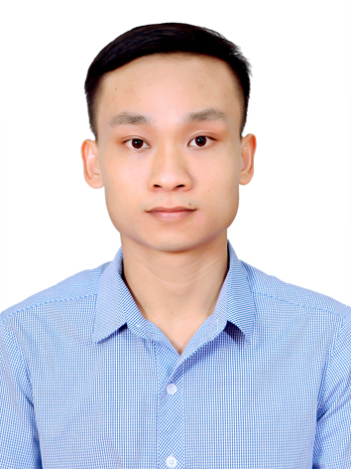
LE DUC HUY

Applying Position: QA staff
CONTACT INFORMATION
Full name: Le Duc Huy
Date of birth: 18/09/1990
Sex: Male
ID card No: 031537403
Address: Thien Kha, Tien Cuong, Tien Lang, Hai Phong
Mobile: 0879016199
Email: huy33391@gmail.com

CAREER OBJECTIVE
I am an experienced professional in Manufacturing (Quality Assurance) and IT Department, with a strong background as a Software Developer and Shipbuilding Engineer. I have a deep understanding of factory operations, quality standards, and production data workflows. My goal is to become an IT Leader at SUN VIGOR VIETNAM SMART TOY, where I can apply my technical expertise to optimize IT systems and contribute to the company's success.
WORK EXPERIENCE
- 06/11/2017 to 25/8/2019: Rorze Robotech.
Position: QC staff

- Manage the performance of inspection staffs based on excel and 7 QC tools.
- Improve productivity and reduce errors for inspection staffs.
- Perform other management tasks as required by the Production assistant manager.
- 26/8/2019 to 20/9/2021: LG Electronics Việt Nam Hải Phòng.
Position: IT staff of QA department

- Build software and macros with Python, C#, VB.net, and VBA to support digital transformation and reduce manual work for QA inspectors.
- Enhance the technical proficiency of QA staff in Excel, PowerPoint, Word, and VBA through dedicated training sessions.
- 21/9/2021 to PRESENT: KYOCERA Document Technology Hai Phong.
Position: IT staff

- Implement security solutions from Japan headquarters.
- Provide technical support and troubleshooting for company computers.
- Conduct VBA training for department members.
- Develop "Kagangta Antivirus" to prevent virus spread across the company.
- Develop a data entry system, reducing 3 headcounts.
- Build an RPA for SAP inspection approvals, reducing 1 headcount.
- Apply AI to develop automated PDF splitting software.
- Apply AI to build a Voice Recognition (Speech-to-Text) to input measurement data.
- Develop management software for sample parts inventory.
- Build a Web Extension for automated form-filling on Parts certification websites.
- Develop Python software to automate inspection result files.
- Develop C# software for batch TIF to PDF conversion.
- Develop C# software for computer-based testing.
- Build a website for smartphone-based part data matching.
- Build software to manage Part inspection workflows.
EDUCATION
- 10/2008 – 05/2012 Vietnam Maritime university with a good engineer degree. (Specialty: Naval Architect).
HONORS & AWARDS
- Scholarship in 1st semester 2010 – 2012.

PROFESSIONAL SKILLS
- Proficient in computer installation and troubleshooting (software).
- Able to program software and macros using Python, C#, VB.net, and VBA to automate tasks and digital transformation.
- Able to build RPA solutions to automate data entry.
- Able to develop web extensions and web platforms for data matching and storage.
- Good command in English.
- Good communication and presentation skills.
- Able to work independently and within a team under pressure.
- Creative, high discipline.
- Quick-learner, self-confident and active.
- Hard working, well-organized and high sense of responsibility.
HOBBY
- I like jogging, workout with my friends.
- I like learn Japanese also.

